Quantum Fiber - 360 WiFi (QF Tech Assist)

Table of Contents

1.0 Overview 3
2.0 Effective Date 3
3.0 Related Links 3
4.0 360 Wifi Overview 3
5.0 Ordering and Removing 360 WiFi 4
6.0 SSID and Password/The Quantum Fiber App 4
7.0 Identifying a 360 WiFi7 Customer 4
8.0 Tech Assist Scenarios 5
8.1 Onboarding Pods Scenarios 5
8.2 Installation Equipment (Technician is onsite) 5
9.0 SmartNID Activation Troubleshooting 6
10.0 Claiming and Activating SmartNIDs or Pods 6
10.1 Claiming Pods 6
10.2 Unclaiming Pods 7
10.3 SmartNID Active but Pod Does Not Activate 7
10.4 Pod Mismatches 8
10.5 Updating Pod Serial Numbers 11
10.6 Sync Pods / Correct Pod Count 11
11.0 Troubleshooting 12
11.1 If a Pod cannot be Added 12
11.2 SSID Broadcasting Issues 13
11.3 How to Factory Reset a Pod 14
11.4 Troubleshooting Ethernet connected devices 14
11.5 What does the LED light on the Pod mean? 14
11.6 Additional factors 15
12.0 Third Party Equipment 16
12.1 Third Party Equipment Requirements 16
12.2 Third Party Troubleshooting 17
13.0 Document Management 17

Overview

Target Audience | QF Programming | QF Facility Support
Impact/Benefit | This document outlines how to assist Field Technicians with 360 WiFi issues.
Reason for Change | Added the following sections:  - Identifying a 360 WiFi7 Customer  - If a Pod cannot be Added  - SSID Broadcasting Issues  - How to Factory Reset a Pod  - Third Party Troubleshooting  Added the note to the Claiming and Activating SmartNIDs or Pods section to include important note about W1701K pods having to be removed and added back to the account after ONT/SmartNID Swap.

Effective Date

Effective Date | Expiration Date
11/10/25 | Until Further Notice

Related Links

Link and Name
Quantum Fiber - SmartNID info (QF Tech Assist).docx
QMate (QF Tech Assist and QF Structure Load).docx
Quantum Fiber - WiFi Troubleshooting (QF Tech Assist).docx
Visit the library to view all documents: MMOE Library

360 Wifi Overview

360 WiFi creates a network throughout the home or business to ensure devices receive the best connection possible. This makes spotty, inconsistent connections, and voids without the Internet a problem of the past.

It also includes a primary control system that routes and directs traffic to connected and Smart Home / Internet of Things (IoT) devices. Reducing slow-downs, parental controls, and enhanced cyber security is available and activated.

Axon Cyber Security

Block suspicious activity in real-time on every connected device
- Online safety is important, especially for families. Set age-appropriate content filters to block or approve specific sites
- Details of every ransomware, malware, virus, botnet, phishing, or other online attack are available in the app

Ordering and Removing 360 WiFi
The customer should use the website to order new service, add 360 WiFi to existing service, or to disconnect existing service, and to return equipment.

SSID and Password/The Quantum Fiber App
Customers should utilize the QF App to establish a SSID and Password.

If the customer purchased their phone out of the country, for example, the customer purchased an iPhone in Germany, they will have issues trying to download the app. The customer should update their region details in the settings menu to be able to view the US version of their store.

See more information in the Tech Assist Scenarios section of this document.

Identifying a 360 WiFi7 Customer
In Salesforce:
- Look for a Customer has 360 WiFi7 account note in the highlight panel.
- Review the Assets Panel for WiFi7 equipment as shown below:
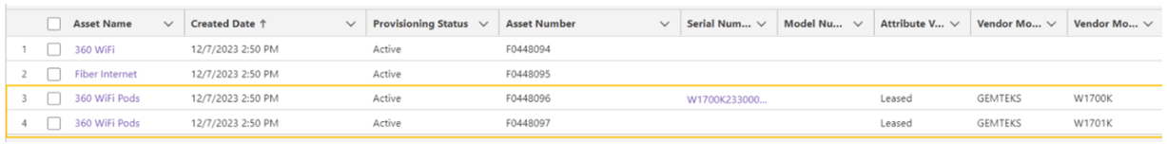
In QMate, the Home Network view will show an icon for Home Wifi with a WiFi 7 flag:

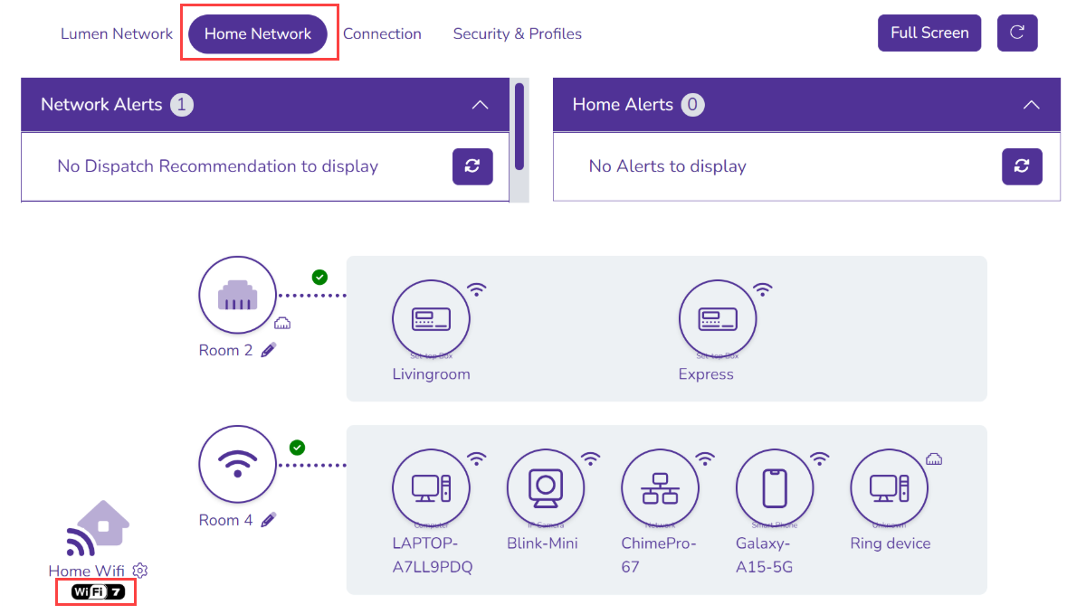

Tech Assist Scenarios

Onboarding Pods Scenarios
Every time a tech goes out to install 360 WiFi pods, a WiFi Survey must be completed to determine if additional pods are needed, and if so where to place them.

Scenario 1: If the customer has an older device that does not support the app (minimum requirements of Android version 4.4 or IOS version11.0 are required), the technician will use Tech2Go to add the pods to the account and create the SSID and password.

Scenario 2: If the customer does not want to download the app or use the app, the technician will use Tech2Go to add the pods to the account and create the SSID and password.

Installation Equipment (Technician is onsite)

New Install – Customer says “I don’t want the 360 WiFi”.
- Pods are not installed.
- The technician completes the order and only installs the SmartNID.
- The technician will direct the customer to the managed portal to remove the 360 WiFi.

New Install – Additional pod(s) needed
- The technician installs the correct number of pods as needed based on the recommendation from the wifi survey.
- The technician uses the Tech2Go-"Adjust Pod Count" option to add or remove the amount of pods on the order.

Divorced/Roommate Situation or using pods from one account to another
- Pods need to be returned by the original account holder. The new tenant/account holder must order the service in their own name with their own contact details.
- Note: If the customer's account is canceled for any reason, they will need to send back the original pods from the first account and order new pods. They cannot be transferred to the new account.

SmartNID Activation Troubleshooting
If a SmartNID fails to activate, follow the steps in the Troubleshooting SmartNID Activation section of the Quantum Fiber – SmartNID document. The link for this can be found in the Related Links section of this document.

Claiming and Activating SmartNIDs or Pods
Note: It has been discovered that when a SmartNID is swapped, the system does not automatically trigger a DHCP refresh for W1701K pods. After swapping an ONT/SmartNID all W1701K pods must be removed and then added back to the account. Refer to Removing Pods, Unclaiming Pods, and Adding Pods sections of the QMate document for process of unclaiming and adding Pods.

Claiming Pods
If unable to claim a SmartNID or pod, especially in Instant 360 properties where devices may associate with the incorrect account, proceed as follows:

Step | Action
1 | Before attempting to claim pods, the following must be verified in QMate:  - SmartNID must be Onboarded  - Digital Twin for SmartNID must be Active  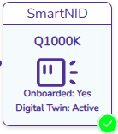
2 | In QMate, go to External Tools.  Select Device Search  Search by Serial Number only.
3 | Review the Account External ID carefully. Confirm it matches the customer’s Salesforce Account ID. If there is a mismatch:  - Reconfirm the serial number.  - Attempt to unclaim the device.  - If unclaiming the device fails, agents should escalate via contacting a SME or Lead.
4 | If the Account IDs match:  - Clear the IP lease.  - Manually factory reset the SmartNID or pod.

Unclaiming Pods
Step | Action
1 | Perform a device search by serial number or DTN. When selected, a search form will popup. Results will be displayed underneath the search bar.  Note: Device Search is accessible via both External Tools and Home WiFi.  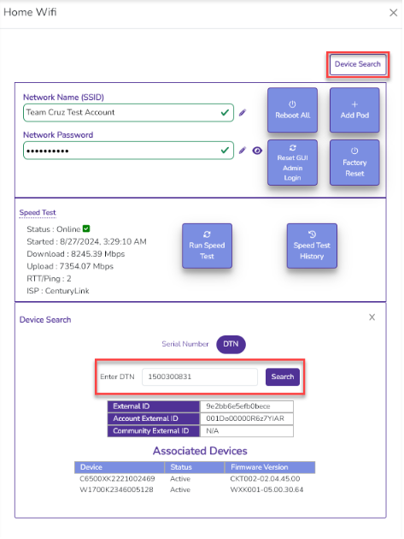
2 | Searching by Serial Number now displays the associated DTN.  Users can Unclaim Pod or Unclaim SmartNID directly from the Device Search screen.  The Unclaim button under the search bar has the same functionality as in the Associated Devices table.  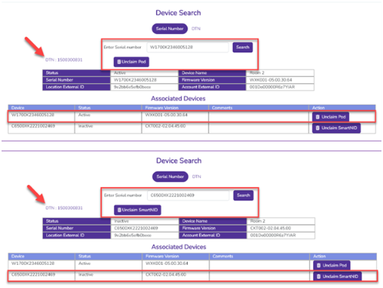

SmartNID Active but Pod Does Not Activate
Step | Action
1 | Clear the IP Lease.
2 | Factory reset the SmartNID.
3 | Once the SmartNID is active, allow up to 3 minutes for the pod to activate.
4 | If pod is still inactive, power cycle it.
5 | If still inactive, perform manual factory reset on the pod.
6 | If the issue persists, replace the pod.

Pod Mismatches
IMPORTANT! WiFi Salesforce Pod Discrepancy issues will require a case to the analyst to resolve. Follow the steps outlined in the Creating an Analyst Support Case section of this document.

Example: Assets in Salesforce don’t match what the technician installed, or the Highlight Panel does not display the correct information. Here, the Assets show Q9500 pods, but the tech installed a W1700, or the Highlight Panel shows WiFi7 Customer but the tech installed Q9500’s.

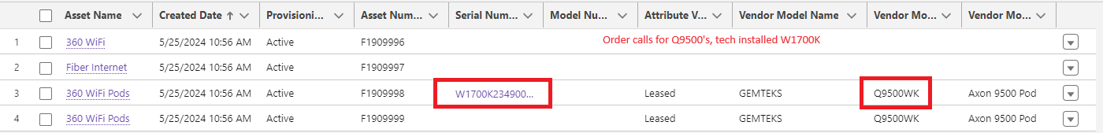

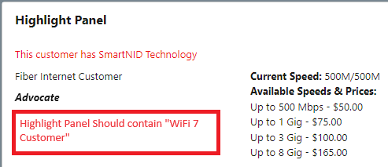

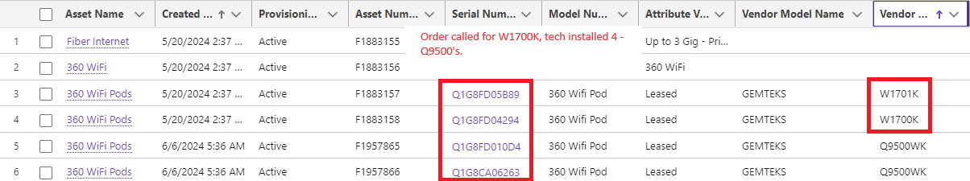

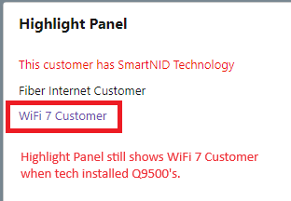

If | Then
Customer (non-Technician) calls in about pods | Transfer to FCST
Pod Serial # needs an update in Salesforce (for existing pods in the Assets) | Refer to section Updating Pod Serial Numbers
Field tech is calling in regarding pod discrepancy, Technician installed additional pods | Field tech should update Mobile App with the proper pod quantity following Field Process.
Customer did not order 360 WiFi on the original order and is trying to add pods | The tech cannot update the Mobile application and should advise the customer to place a new order in the portal for Wifi service and related pods.

Creating an Analyst Support Case
Step | Action
1 | In QF Salesforce, on the Account, select Quick Actions.
2 | Select Create a Fiber/CHIA case.  Select Continue.
3 | Select a Case Type of Analyst Support.  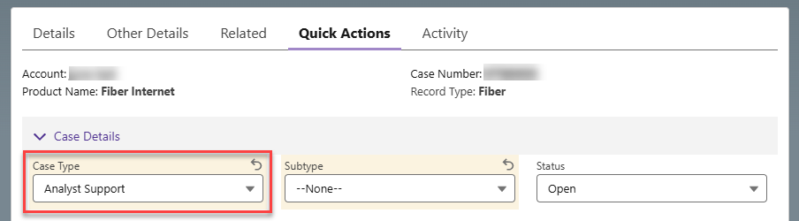
4 | Select a Subtype of Pod Mismatch Sync Request.  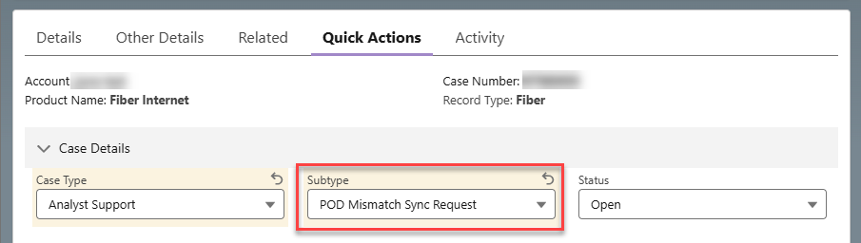
5 | Populate the Tech’s name in the Caller Name field.
6 | Populate the Subject field:  2 character State abbreviation//Pod Mismatch Sync Request  For example:  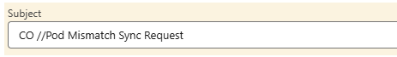
7 | Populate the Notes and Description fields  For Analyst Support cases, include details in the Case Notes:  - Which action is requested? Add Pods or Remove Pods?  - Number of actual pods the customer has & serial numbers  - If Removing - Is this to remove 360 WiFi or just pods?  Tip: Zoom in if needed.

Updating Pod Serial Numbers
Step | Action
1 | On the Account in Salesforce, navigate to the Related List Quick Links and select Assets. Note: Show All may need to be selected first.  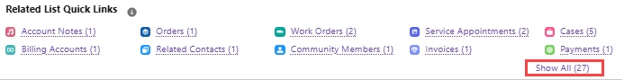  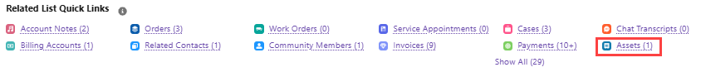
2 | Find the Asset Name of 360 Wifi Pods and select the line item needing to be edited.  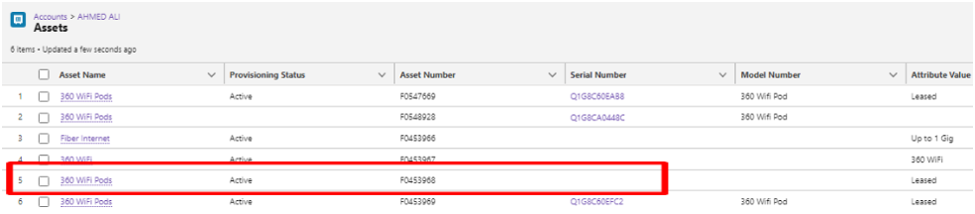
3 | Add the serial number in the open text box and select Update.  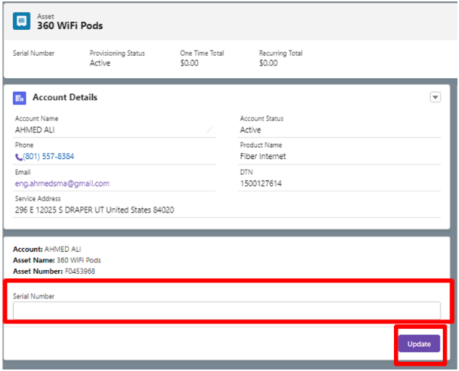

Sync Pods / Correct Pod Count
A new pod sync button has been added to Salesforce to allow agents to manually resolve pod count discrepancies between Salesforce and QMATE/RTO. This can be found on the Account screenin QFSF at the top of the screen.

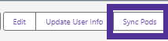

If | Then
Pod is claimed to the account in RTO and shows in QMATE but not in Salesforce | Select the Sync Pods button. It will run a check and add the pod plus serial number to the customer’s account under the Assets section.
An account in Salesforce shows more pods than the customer has in RTO and they do not show in QMATE | Select the Sync Pods button. It will remove any pods that are no longer claimed to the account.
An account has a mix of 9500's and WiFi 7 pods showing in QMATE and they are both plugged in and connected | - The Sync Pods button will not update the pod assets on the account in Salesforce.  - The customer must send back the 9500s  - Once received in the warehouse, the QFSF account is updated to reflect the correct Pod count.
The serial numbers are incorrect but the pod count is correct | Select the Sync Pods button. This will correct the serial numbers.
If a customer has 360 WiFi pods installed but their Salesforce account does not show the 360 WiFi product listed as an asset | Select the Sync Pods button. This action will automatically detect the presence of active pods and add the 360 WiFi product to the account as an asset.

Troubleshooting
If the customer has Q9500WK Pods and the Main Pod is not connecting, but has power, the pod equipment will need to be replaced. Q9500WK Pods are no longer available, and the customer will have to be upgraded to WiFi7 equipment.

If a Pod cannot be Added
Step | Action
1 | A Pod cannot be activated unless the SmartNID is onboarded and digital twin is active.  If not, follow the steps outlined in the Checklist for Onboarding SmartNID and Digital Twin Status section of the QMate document before proceeding to the next step.
2 | Have the Technician check the physical connections  - The main pod (W1700K) must be connected to the SmartNID via an ethernet cable and connected to a power outlet  - Verify the W1700K pod power supply has not been mixed up with the SmartNID power supply  - In order to add a W1701K, the W1700K has to be onboarded and active
3 | If the main pod (W1700K) or the WiFi Mesh pod (W1701K) still cannot be added, have the Technician perform a factory reset on the Pod, then repeat the steps in the Updating the WiFi SSID and Password section of the QMate document.  Note: If the light does not come on after plugging in, rebooting, or hard resetting a pod, then the pod is defective and will need to be replaced.
4 | Validate that the Pod has been pointed to an onboarding server. Follow the steps outlined in the Pointer Request section of the Quantum Fiber – SmartNID Info document.
5 | If a Pod still cannot be added, have the Technician replace the Pod.

SSID Broadcasting Issues
Step | Action
1 | The SSID cannot broadcast unless the Pod is onboarded and digital twin is active.  In QMate, from the Home screen, select Network View, then Home Network.  Verify the Pod has a green check mark to confirm onboarding and digital twin status.  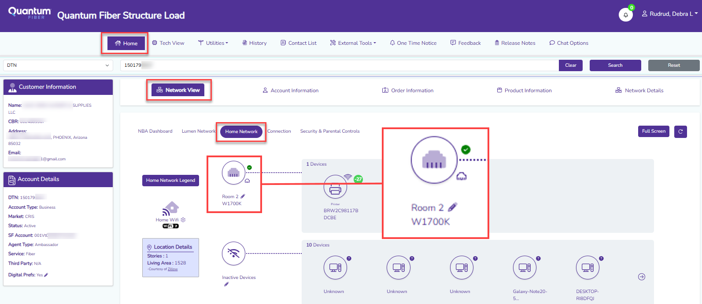
2 | If the Pod is onboarded and digital twin is active, and the SSID is not broadcasting, then see the Updating the WiFi SSID and Password section of the QMate document.
3 | If the SSID is still not broadcasting have the Technician perform a factory reset on the Pod, then repeat the steps in the Updating the WiFi SSID and Password section of the QMate document.
4 | If the SSID is still not broadcasting have the Technician replace the Pod.

How to Factory Reset a Pod
To hard reset/factory reset a Pod:
- Hold down the reset button for 15 seconds
- Once the button is released, the light will change to an amber color and then the pod will reboot

Troubleshooting Ethernet connected devices
  - If the wired device is not connecting to the network, try power-cycling the pod while the device is still connected by Ethernet.

  - Try another Ethernet cable. Ethernet cables can fail and cause a poor or unstable connections.

What does the LED light on the Pod mean?
The LED on each pod is used as an indicator of various hardware and software states. Below is a list of various scenarios in which the LED can help understand what is going on.

Tip: Zoom in to enlarge image if needed.
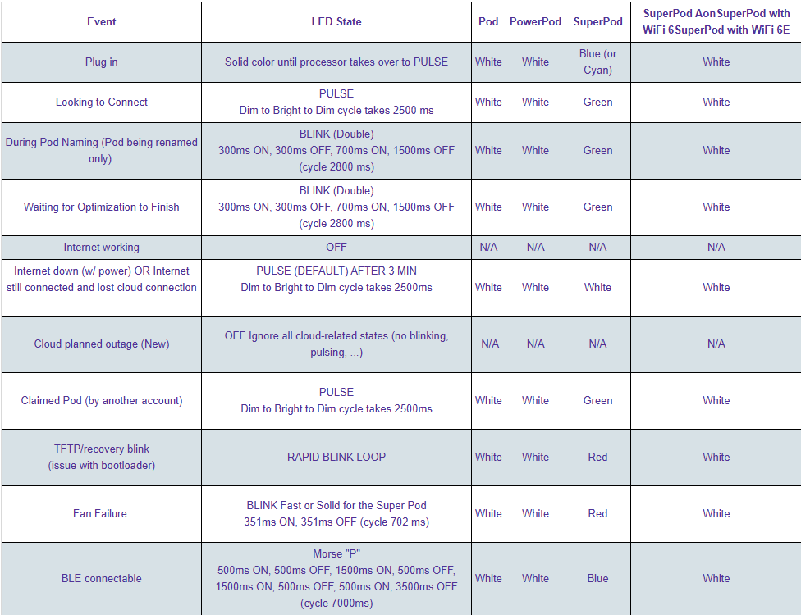

Additional factors

WiFi Interferance
- What: If there is poor connection to certain devices or in certain parts of the home
- Why: This could be caused by conditions unique to the home/property, such as home construction or home décor (example: Mirrors, etc) that can cause WiFi transmission issues.
- Indicators:
  - Only some devices experience issues
  - RSSI values for certain devices are in the red (-108db) in QMate.
    - Note: RSSI Indicator bar in QMate = Green (excellent), Yellow (marginal), Red (poor).
- How to fix: The customer may need to move obstructions or the device may need to be moved away from the obstruction.

Poor Coverage/Underserviced – Inadequate number or placement of Pods
- What: There is poor connection to some devices
- Why: WiFi coverage is inadequate due to number of or placement of Pods
- Indicators:
  - Only some devices are affected
  - RSSI indicators are yellow or red
    - RSSI value in yellow at -74dBm
    - Note: RSSI Indicator bar in QMate = Green (excellent), Yellow (marginal), Red (poor).
  - Pods are connecting to other Pods and not the main Pod
- How to fix:
  - Determine the location of the pods within the home in comparison to the reported devices with connection issues.
  - Determine if Pods and/or devices can be moved to optimize WiFi coverage.
  - In the rare circumstance where it is determined an additional Pod would resolve the gap in WiFi coverage, the customer would need to order an additional Pod(s).
    - Techs do not get dispatched on non-360 WiFi Accounts

Oversaturation/Too many Pods
- What: Devices are experiencing the dropping of WiFi signal
- Why: Too many Pods are within the home causing overlapping channels
- Indicators:
  - A smaller home is described and there are 2+ Pods in the home.
  - RSSI values on all Pods are -30 dBM or lower
    - Note: RSSI Indicator bar in QMate = Green (excellent), Yellow (marginal), Red (poor).
  - Review the RSSI indicator on the Pods, making note of if it is green and has no connected devices
  - Devices drop and reconnect randomly.
- How to fix:
  - Remove a Pod (with the low RSSI) or move Pods further away from each other
  - Determine which devices tend to drop WiFi signal and have the closest Pod removed/disconnected

Third Party Equipment

To connect to WiFi, customers will either select 360 WiFi or bring their own WiFi solution (if the option is available in the buy-flow).

If a customer declines 360 WiFi and indicates they want to provide their own equipment, a Third Party Equipment Requirements notice will appear to the customer.

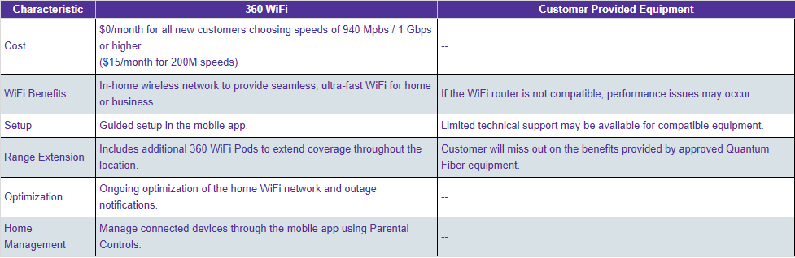

Third Party Equipment Requirements

If a customer declines 360 WiFi and indicates they want to provide their own equipment,
the following information will appear:

If you did not choose 360 WiFi, you will need to provide your own equipment for WiFi
connectivity.

Using the Quantum Fiber provided modem and the 360 WiFi solution will allow you to
get the most out of your Quantum Fiber service. If you want to use different equipment,
we recommend using approved Quantum Fiber compatible equipment.

The criteria for compatible router(s) that will work with your Quantum Fiber service are
listed below. If your router is not a compatible router you may experience performance
issues with your service and you will be responsible for any troubleshooting. If you have
questions, please chat with a Fiber Success Agent.

A Third-Party Router must support:
- 1 Gbps Ethernet WAN port
- DHCP to obtain WAN IP Address
- Firewall support (recommended)

Maximum throughput that meets your purchased speed Wireless Access Point
selection to support:
- Latest WiFi technologies that are also available in your wireless clients (at least 2×2
- radio with 802.11AC and/or 802.11AX)
- Accurate auto-channel selection
- Ethernet port must forward packets between LAN and WAN, at the same rate as
- purchased speed

Use of your own device will impact access to these features:
- Security Features such as malware protection, antivirus, and content protection
- Access control to allow or block certain devices from connecting at certain times
- Wireless Optimization, including Dynamic Channel Optimization and Band Steering
- Technical support for troubleshooting
- Pro-active monitoring of your service above the physical layer

Are you sure you want to pass up on choosing 360 WiFi?

Third Party Troubleshooting
Step | Action
 | Verify there is no outage.
 | Confirm the ONT is online and has the correct programming.
 | Verify the Ethernet port is enabled and detects a device plugged into it.
 | The customer would need to reseat the Ethernet cord between the ONT and the Gateway.
 | Reboot both the ONT and the Gateway.
If the Gateway is still not pulling an IP, advise:
- The Gateway has to be capable of handling gig speeds
- VLAN tagging needs to be to 201 under the WAN settings
  - This requires logging into the Gateway’s GUI to change. The customer may need to refer to the manufacturer’s technical support team for further assistance
  - A Tech will not be dispatched

Document Management

Document Management
AUTHORS
Author | SME |  | Name |  |  |  | Telephone Number | E-mail Address
X |  |  | Rachel Barlow |  |  |  | N/A | Rachel.barlow@lumen.com
X |  |  | Debra Rudrud |  |  |  | 608-615-4215 | Debra.Rudrud@lLumen.com
X |  |  | Kyle Field
REVISIONS
Date |  | Issue |  | Revised By |  | Comments
11/10/25 |  | 1 |  |  |  | Initial Version. Copied information from the KIT document  360 WiFi - Overview for the Lumen to NetworkCo transition.
12/12/25 |  | 2 |  | Debra Rudrud |  | Added the following sections:  - Identifying a 360 WiFi7 Customer  - If a Pod cannot be Added  - SSID Broadcasting Issues  - How to Factory Reset a Pod  - Third Party Troubleshooting
12/17/25 |  | 3 |  | Debra Rudrud |  | Added the note to the Claiming and Activating SmartNIDs or Pods section to include important note about W1701K pods having to be removed and added back to the account after ONT/SmartNID Swap.
APPROVAL
Name |  |  |  |  | Title |  |  |  | Date Approved
Liz Bordano |  |  |  |  | Manager – Mass Markets Ops Excellence |  |  |  | Enter date document was approved by Manager  11/10/2025

